SINKO STYLING
ОПТОВЫЙ ПРАЙС-ЛИСТ ДЛЯ САЛОНОВ И МАСТЕРОВ
Фото | Артикул | Наименование | Объём | Оптовая цена | РРЦ
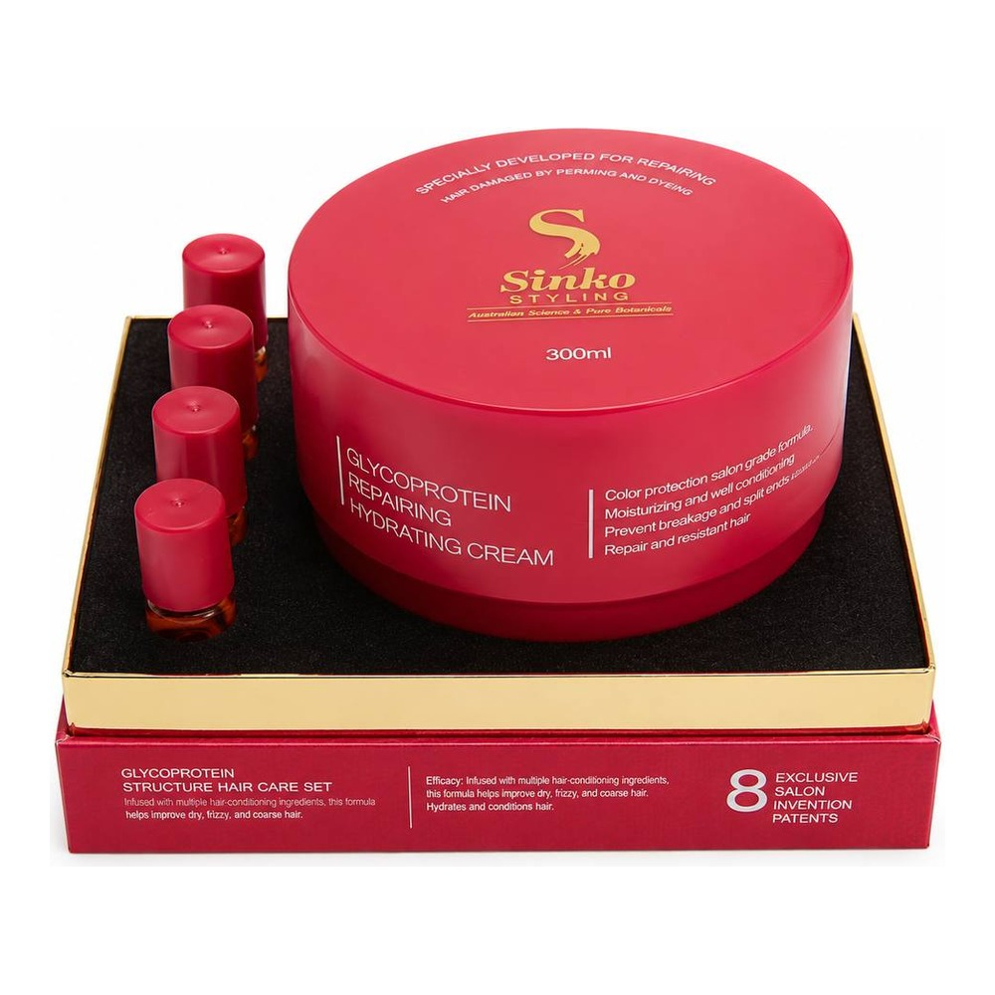 | C151615 | Natural Energy Boost Cream | 500 мл | 980 ₽ | 1 230 ₽
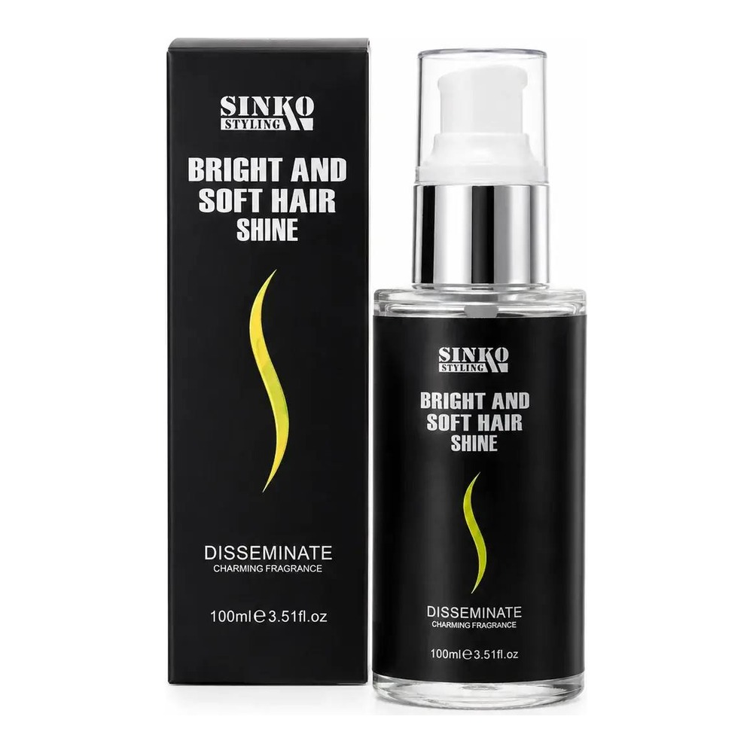 | C104703 | Macadamia Smooth Hair Serum | 100 мл | 660 ₽ | 830 ₽
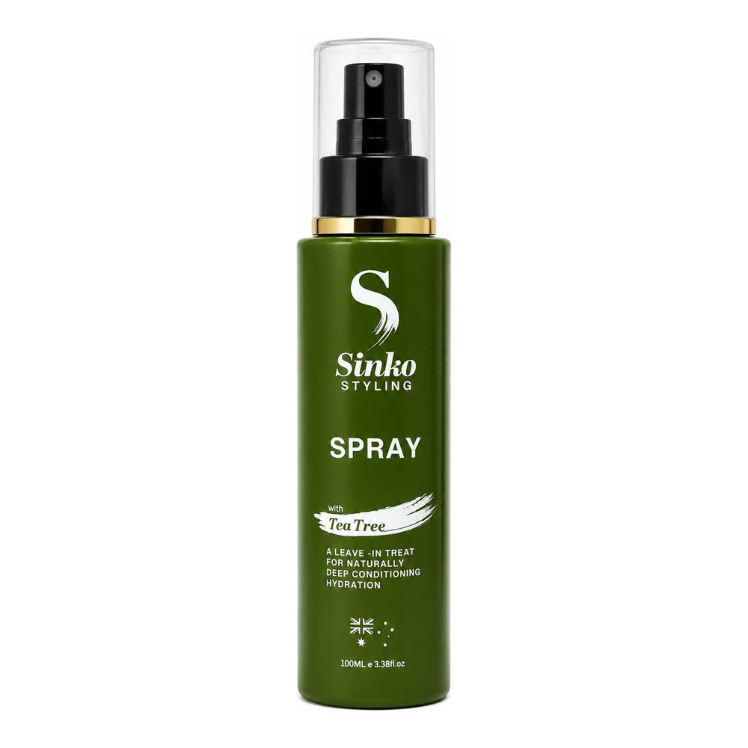 | SKTS100 | Tea Tree Nourishing Spray | 100 мл | 360 ₽ | 450 ₽
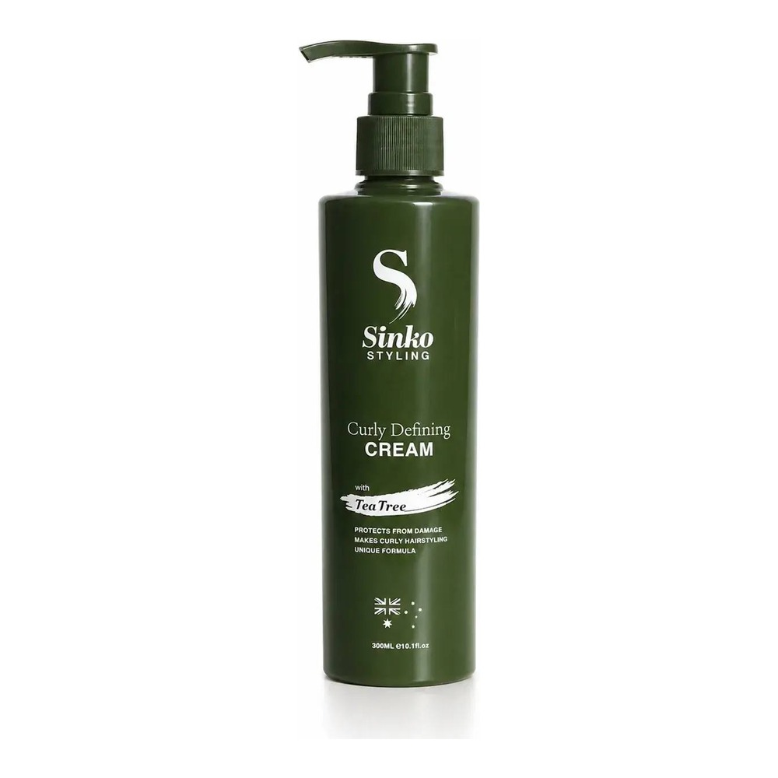 | SKTC300 | Tea Tree Curly Defining Cream | 300 мл | 680 ₽ | 850 ₽
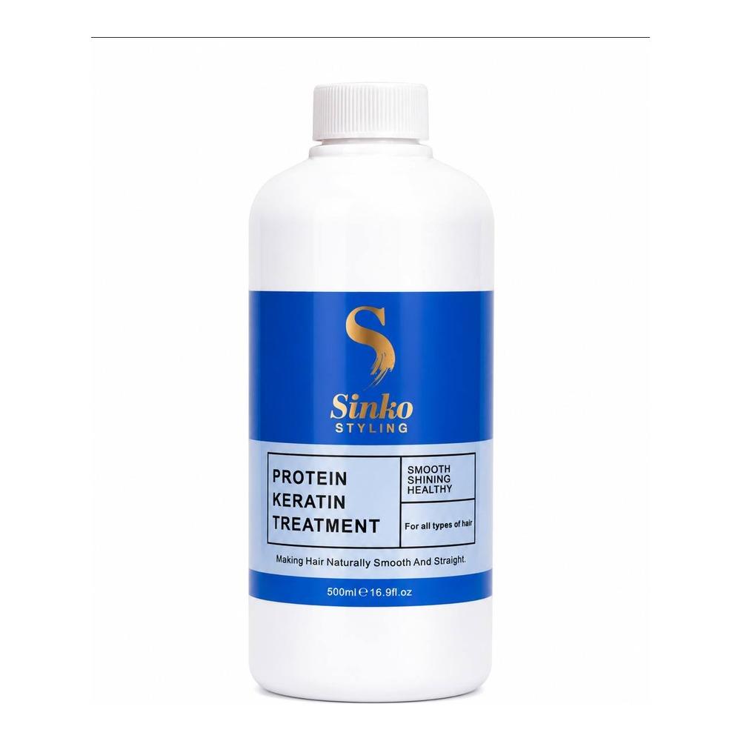 | SKUK501 | Brazilian Keratin Purifying Shampoo | 500 мл | 850 ₽ | 1 070 ₽
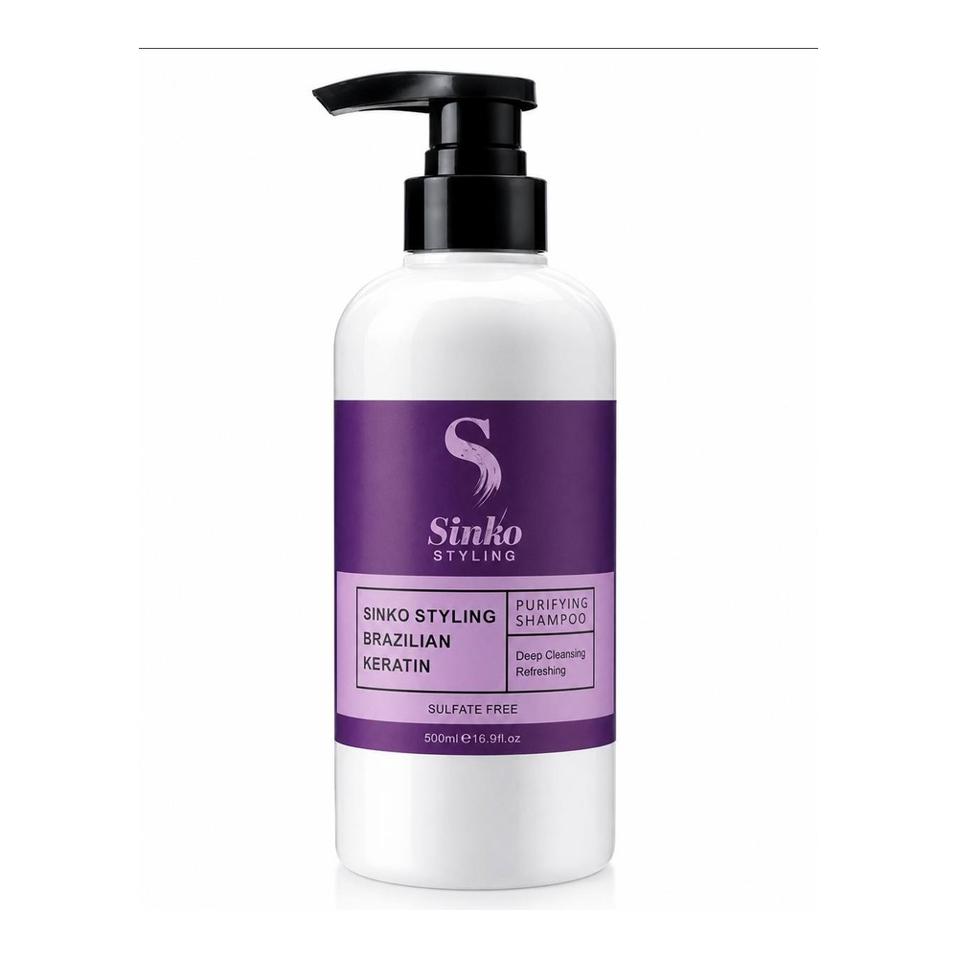 | SKUK5022 | Brazilian Keratin Treatment FM 4% | 500 мл | 1 060 ₽ | 1 330 ₽
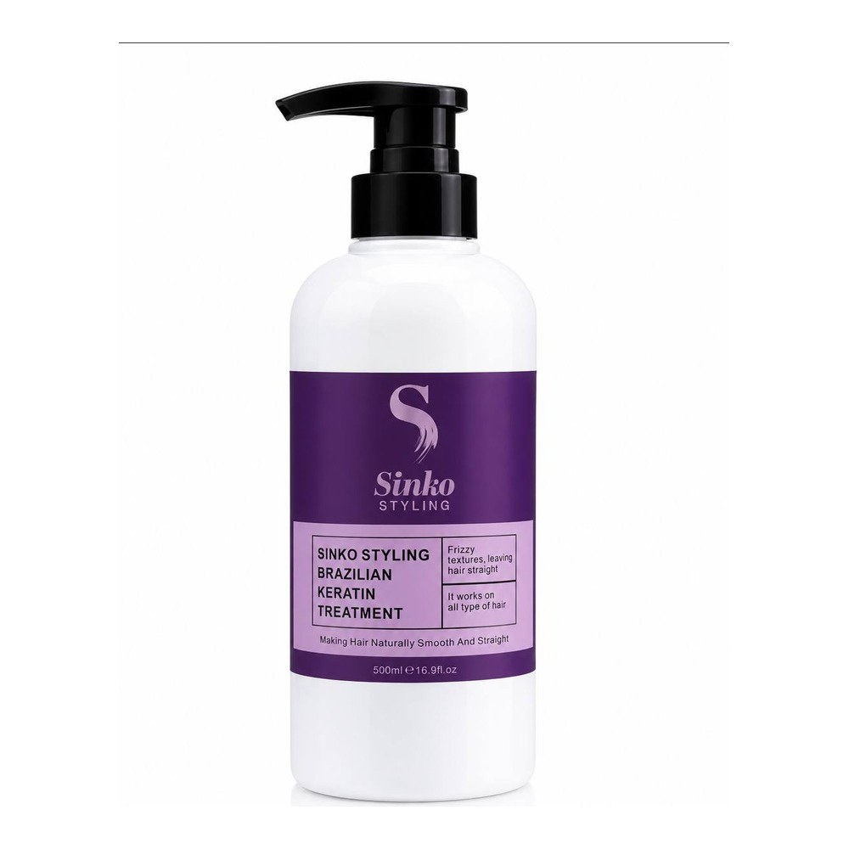 | SKUK502B | Brazilian Keratin Treatment FM Free Blue | 500 мл | 1 740 ₽ | 2 180 ₽
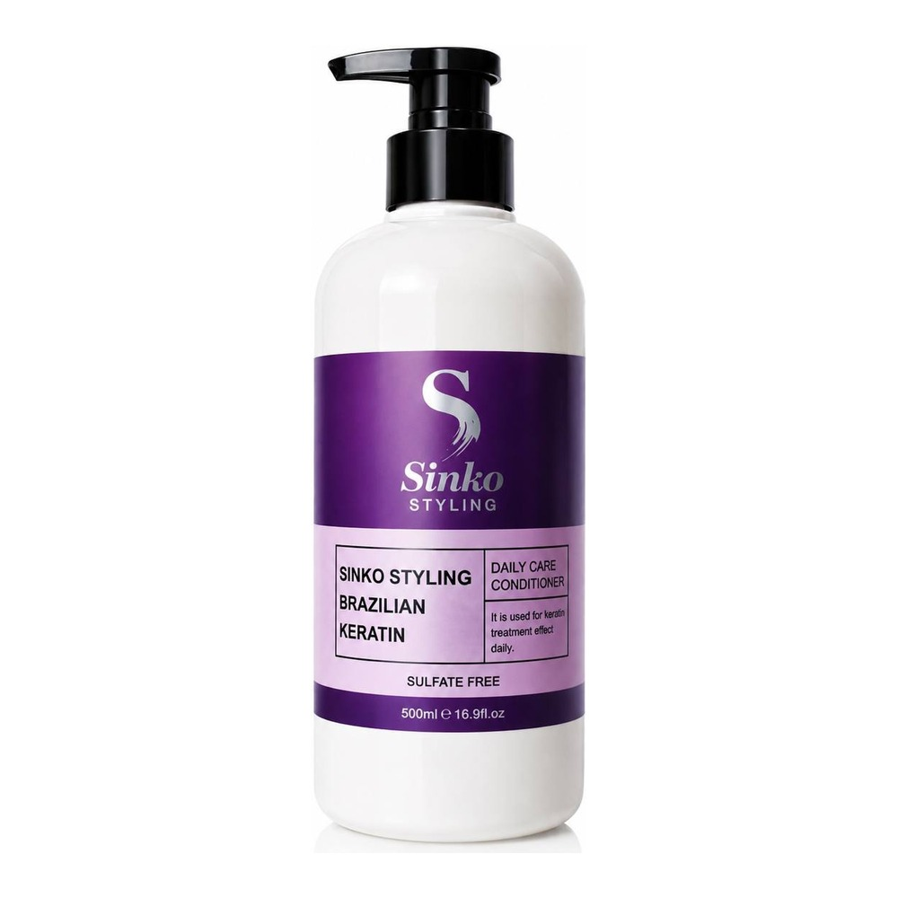 | SKUK503 | Brazilian Keratin Daily Shampoo No.3 | 500 мл | 920 ₽ | 1 150 ₽
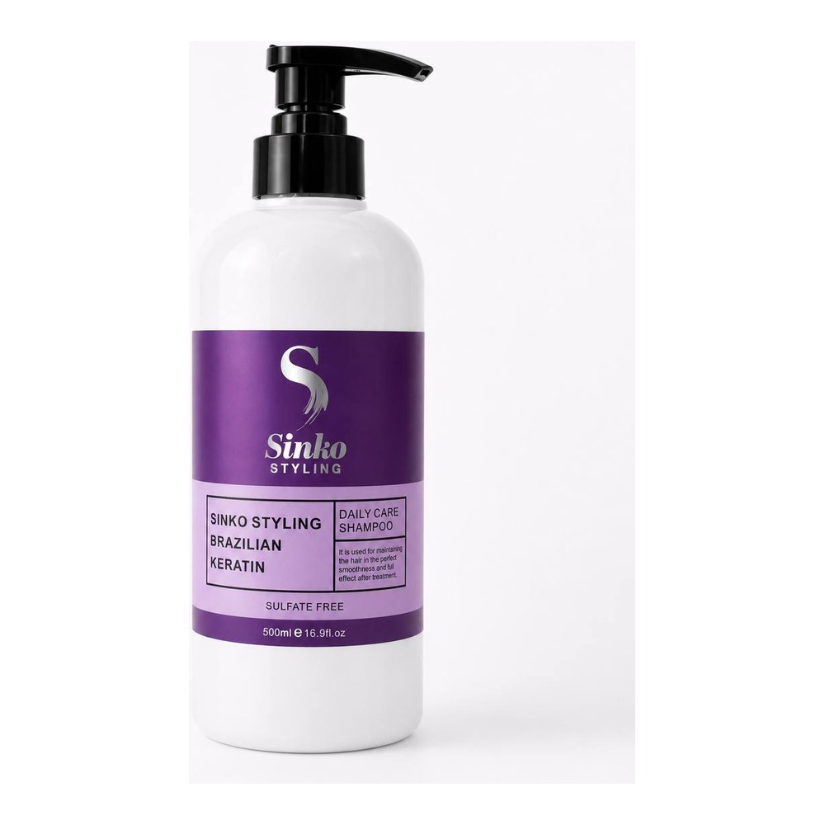 | SKUK504 | Brazilian Keratin Daily Conditioner No.4 | 500 мл | 920 ₽ | 1 150 ₽
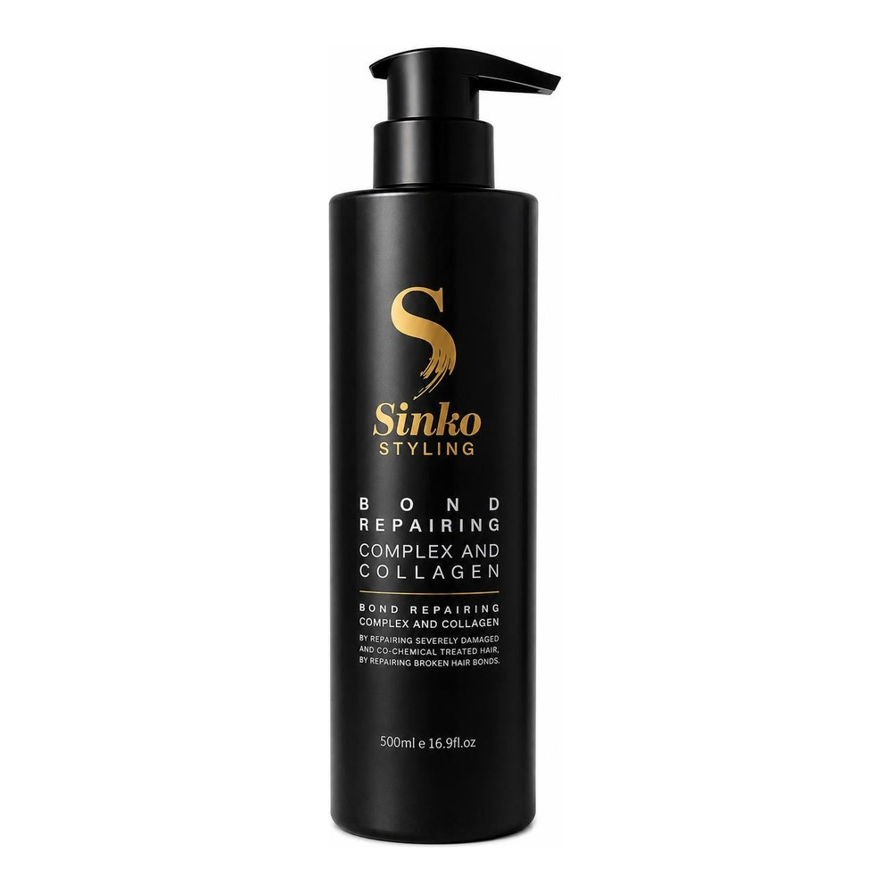 | SKBR500 | Bond Repair Complex and Collagen | 500 мл | 950 ₽ | 1 190 ₽
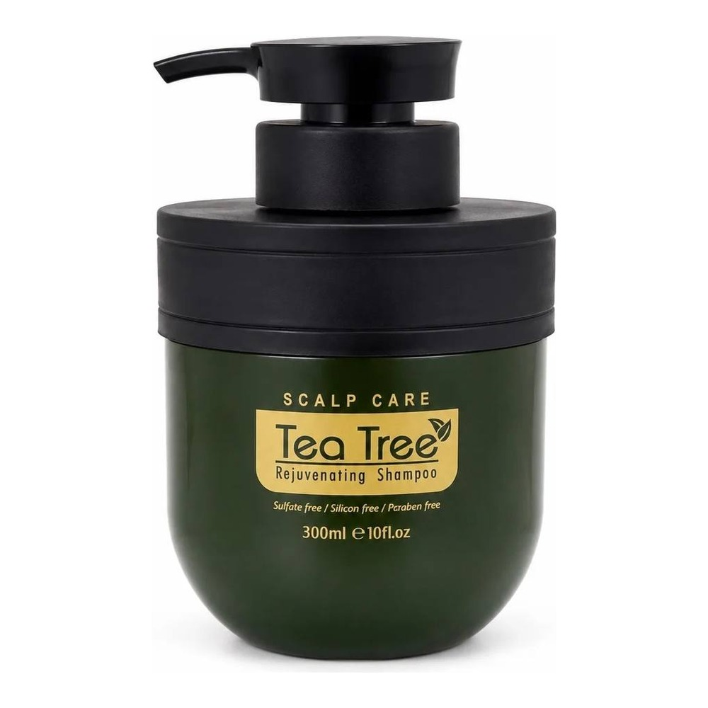 | SKPS220 | Scalp Exfoliating With Tea Tree Oil | 220 мл | 600 ₽ | 750 ₽
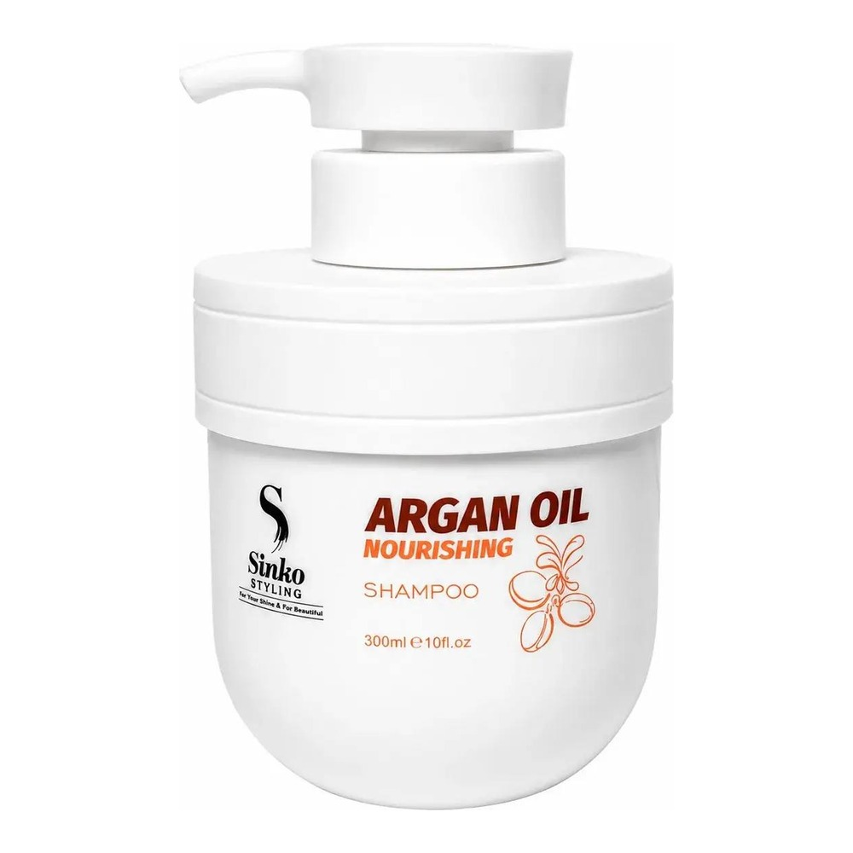 | C151609 | Argan Oil Nourishing Shampoo | 500 мл | 810 ₽ | 1 020 ₽
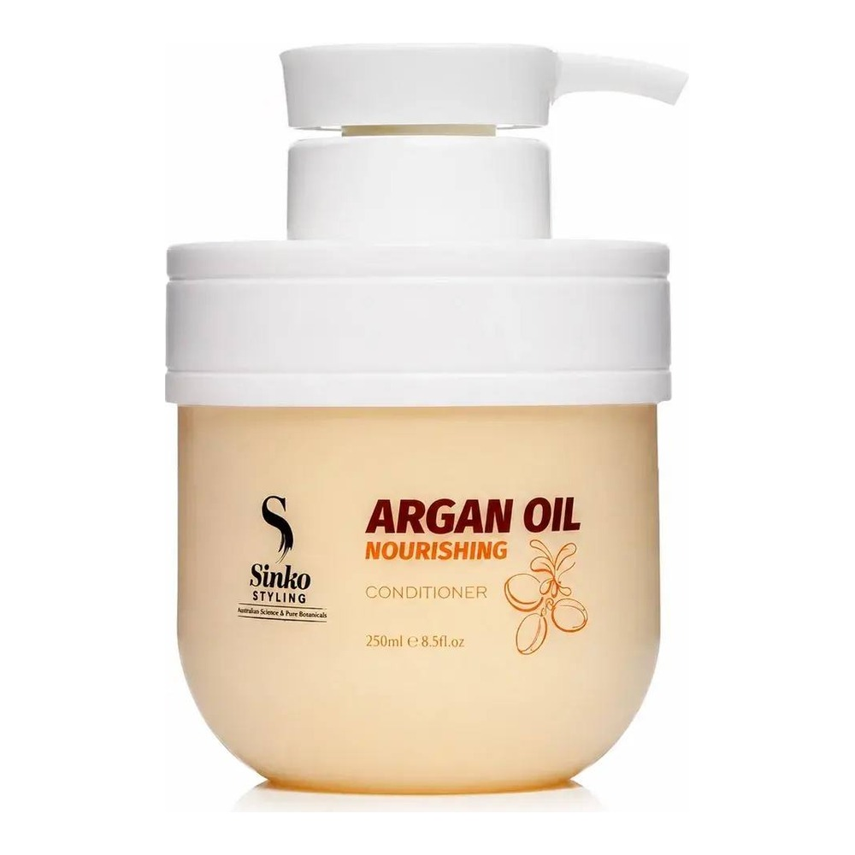 | C151610 | Argan Oil Nourishing Conditioner | 500 мл | 940 ₽ | 1 180 ₽
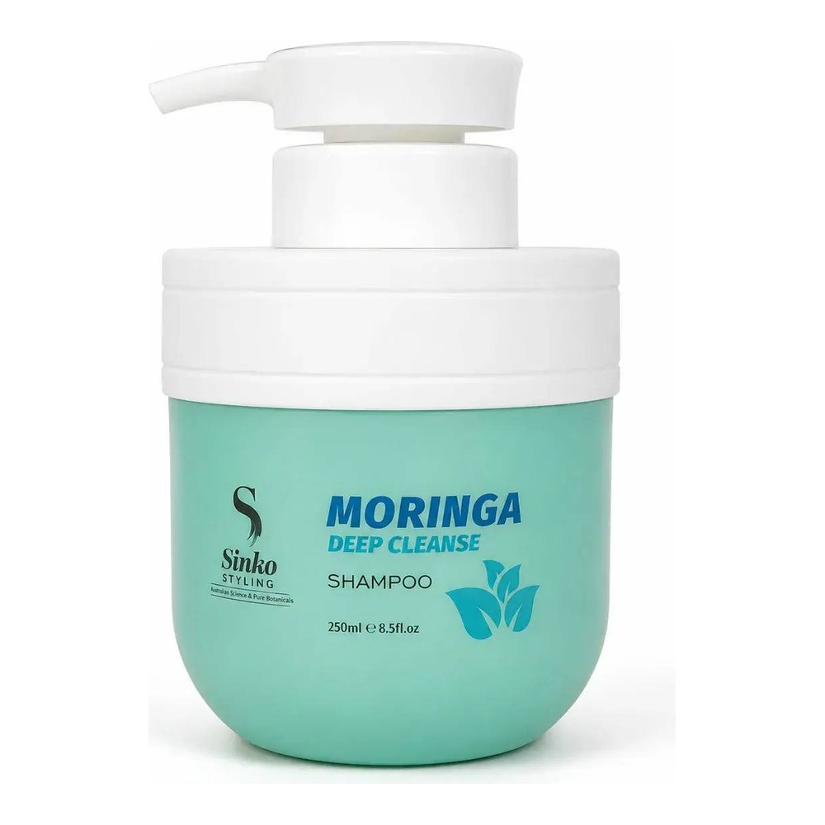 | C151611 | Moringa Deep Cleanse Shampoo | 500 мл | 810 ₽ | 1 020 ₽
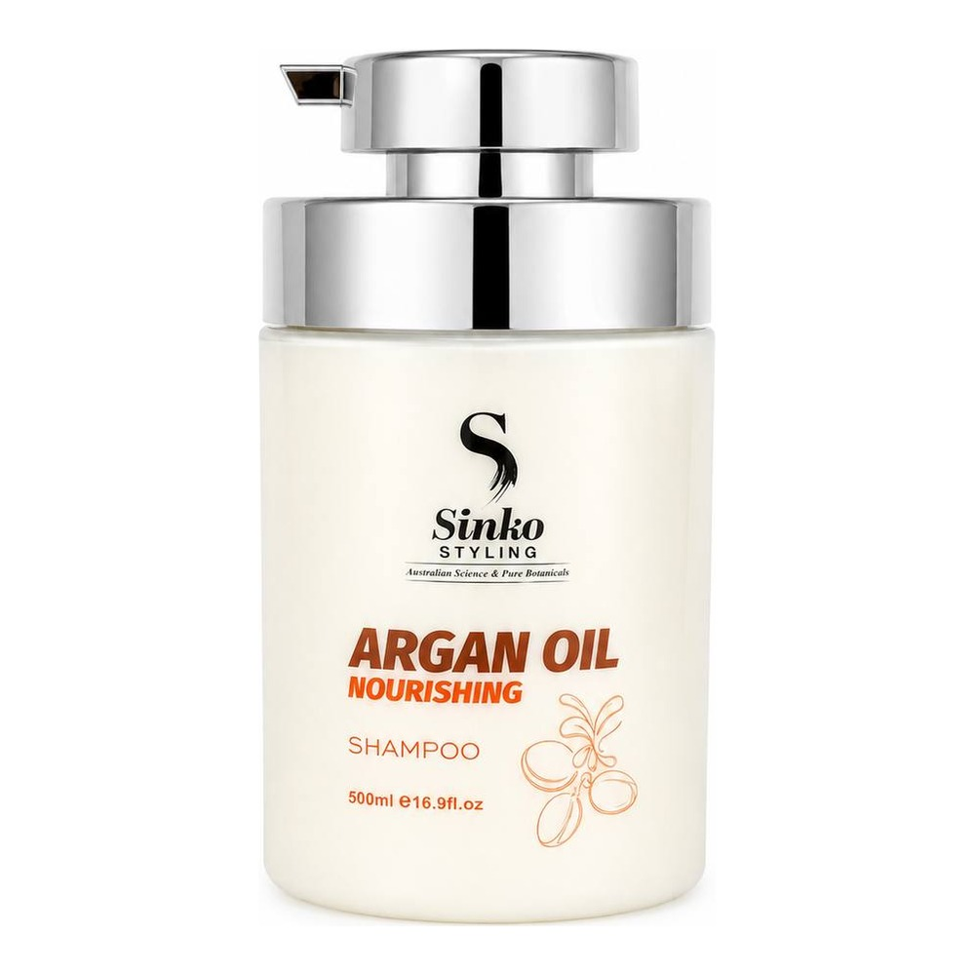 | C151616 | Argan Oil Nourishing Shampoo | 250 мл | 540 ₽ | 680 ₽
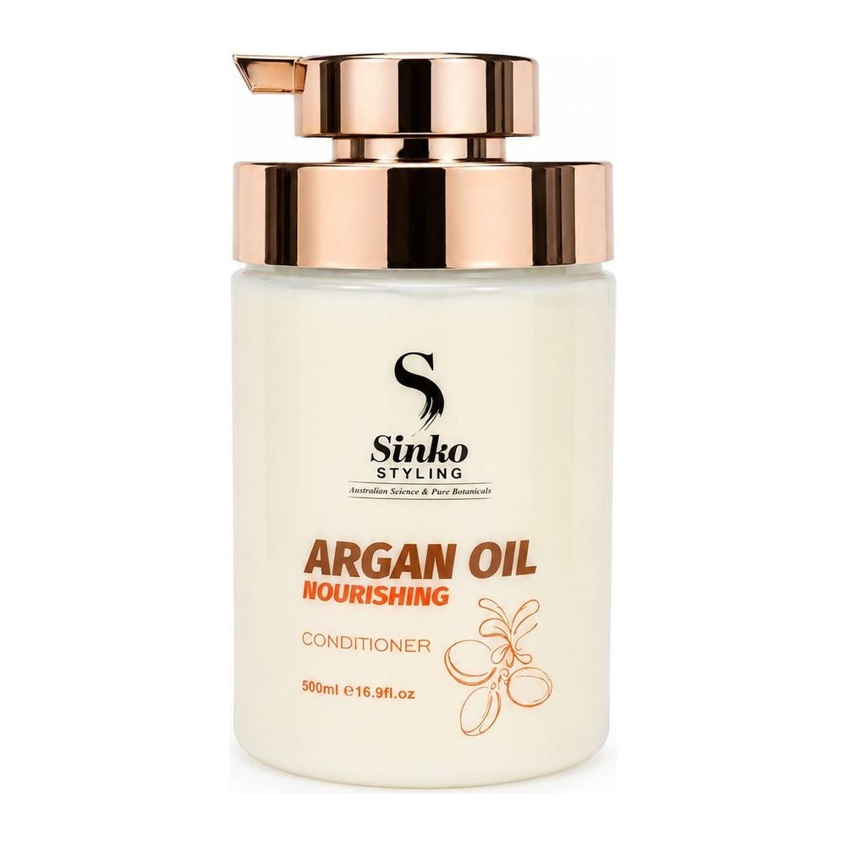 | C151617 | Argan Oil Nourishing Conditioner | 250 мл | 610 ₽ | 770 ₽
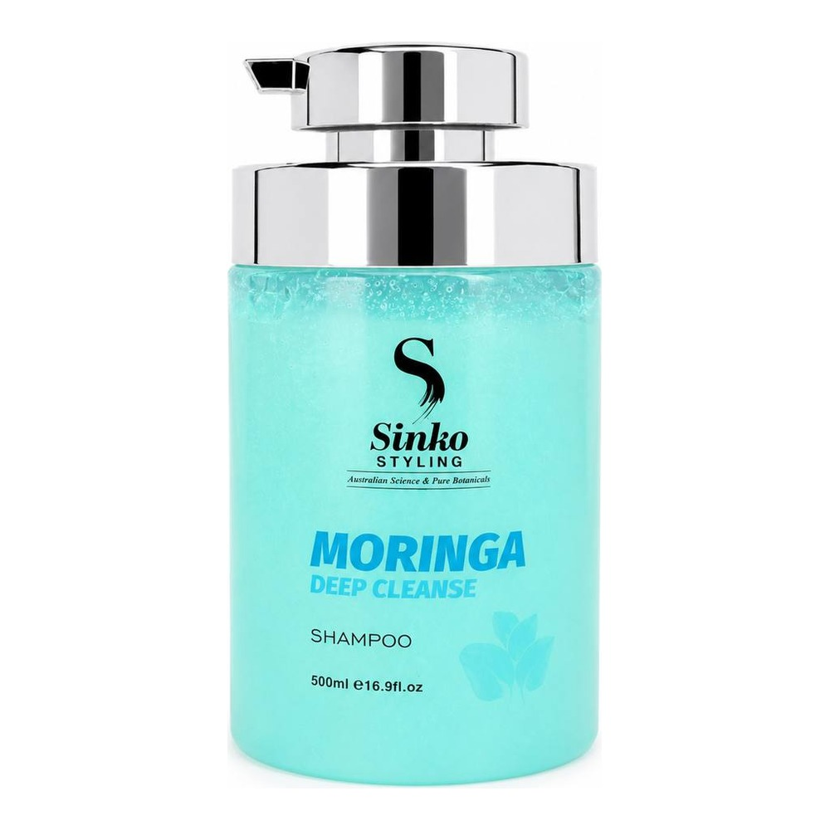 | C151618 | Moringa Deep Cleanse Shampoo | 250 мл | 550 ₽ | 690 ₽
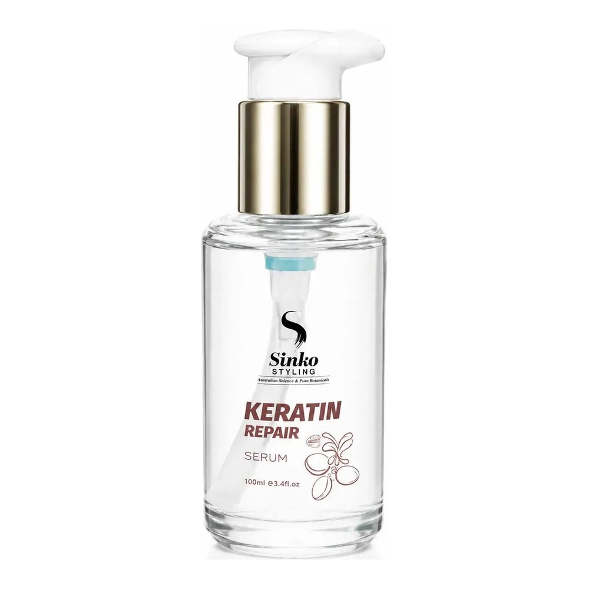 | C151612 | Keratin Repair Serum | 100 мл | 560 ₽ | 700 ₽
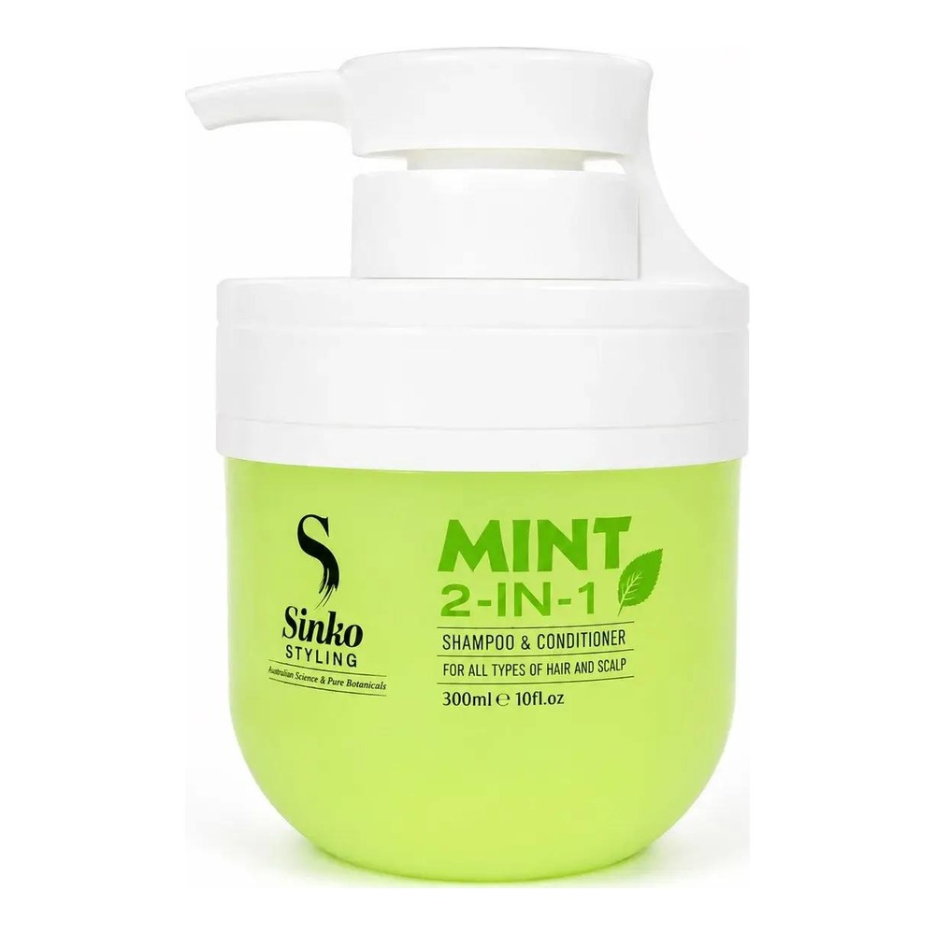 | SKSC300A | Mint 2-IN-1 Shampoo & Conditioner | 300 мл | 690 ₽ | 870 ₽
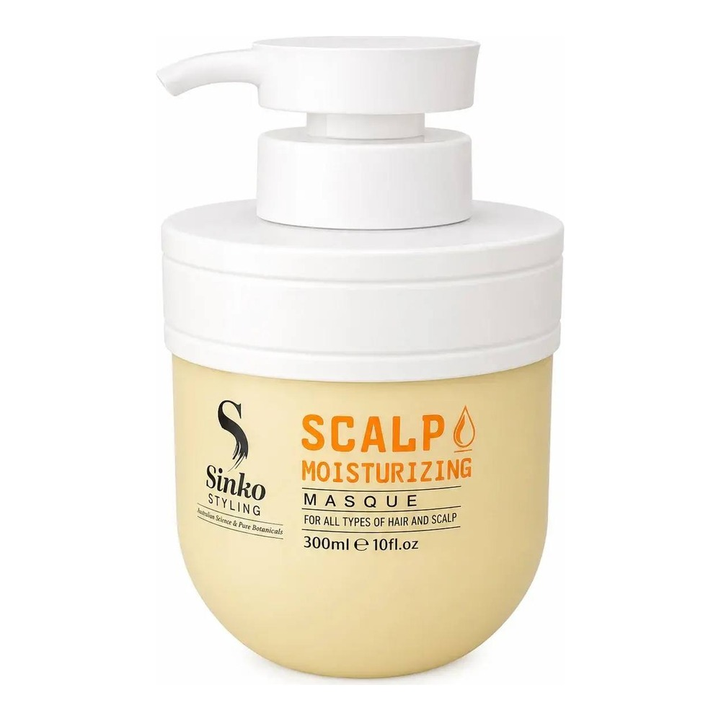 | SKSM300 | Scalp Moisturizing Masque | 250 мл | 580 ₽ | 730 ₽
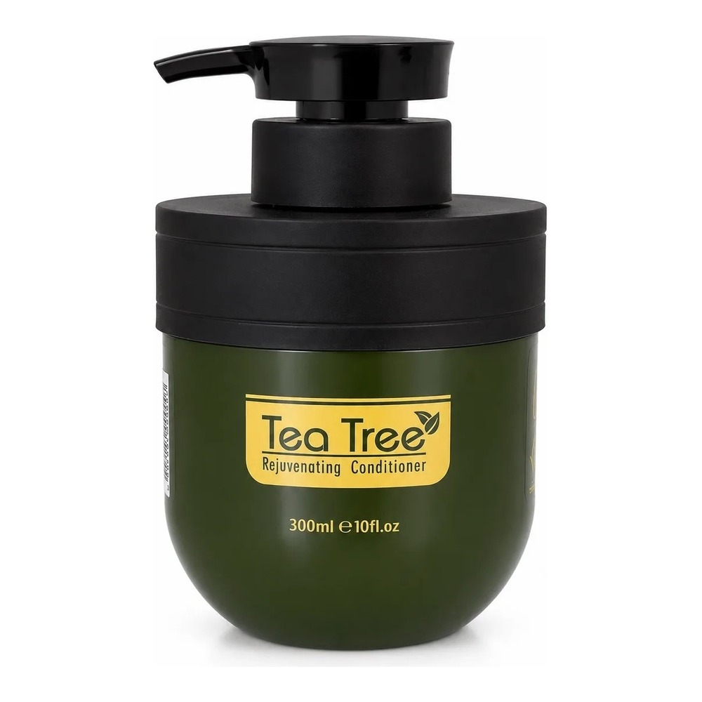 | C151619 | Tea Tree Rejuvenating Shampoo | 300 мл | 660 ₽ | 830 ₽
 | C151620 | Tea Tree Rejuvenating Conditioner | 300 мл | 670 ₽ | 840 ₽
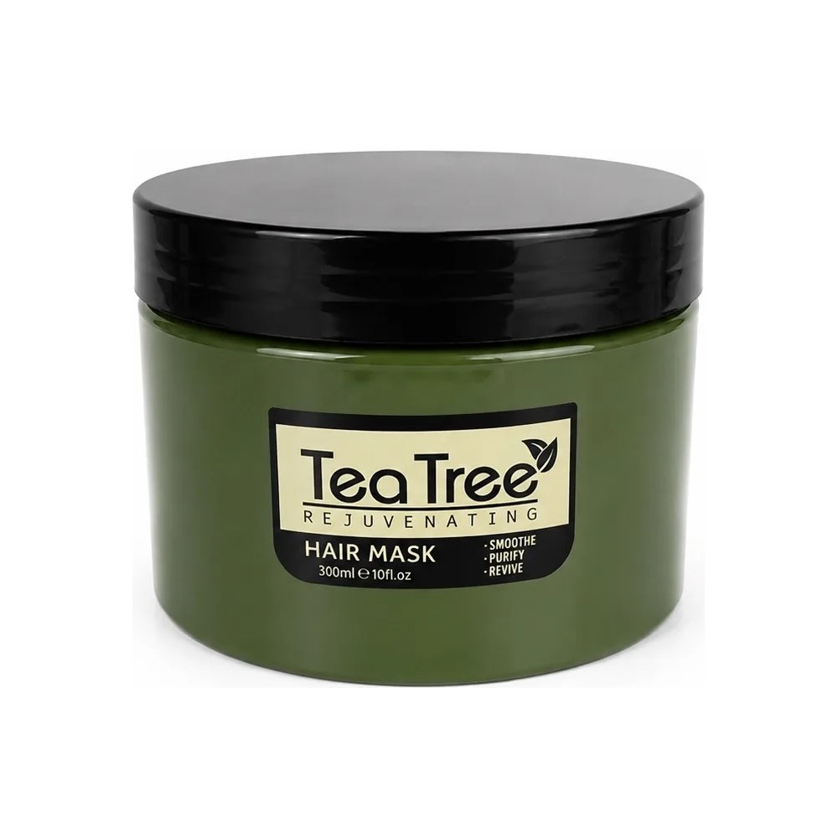 | C151621 | Tea Tree Rejuvenating Hair Mask | 300 мл | 720 ₽ | 900 ₽
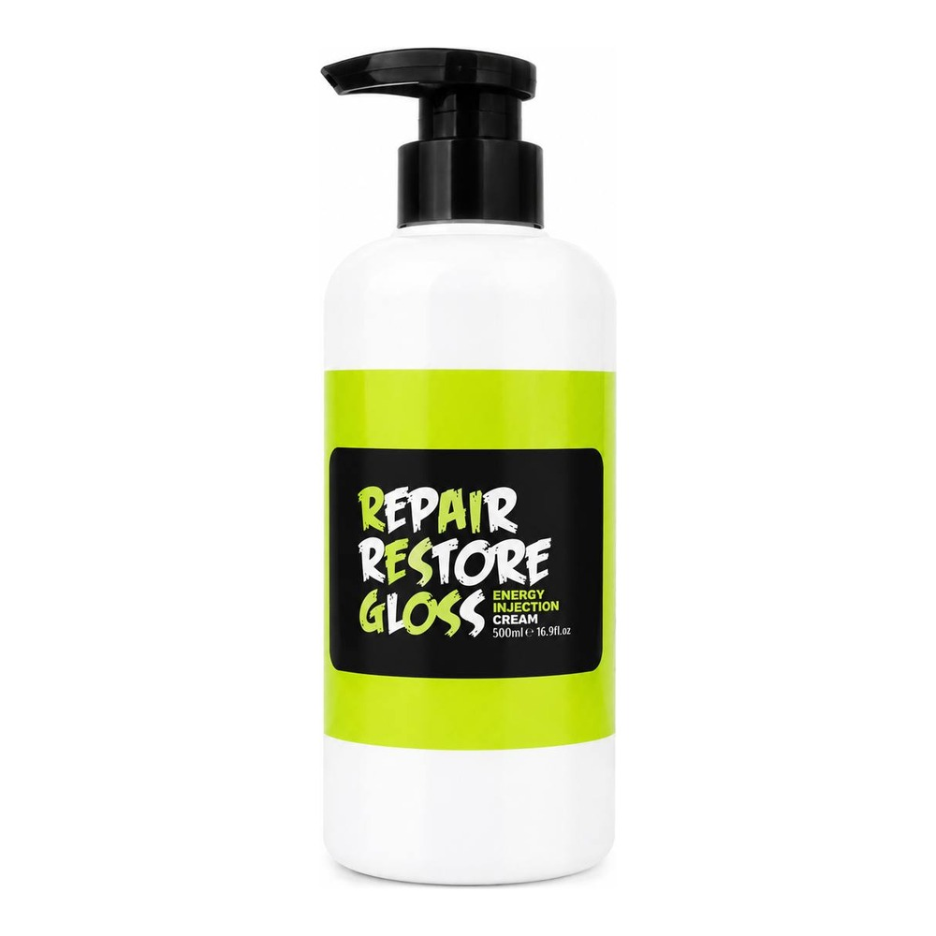 | SKLC200 | Leave In Cream Protection and Hair Treatment | 200 мл | 520 ₽ | 650 ₽
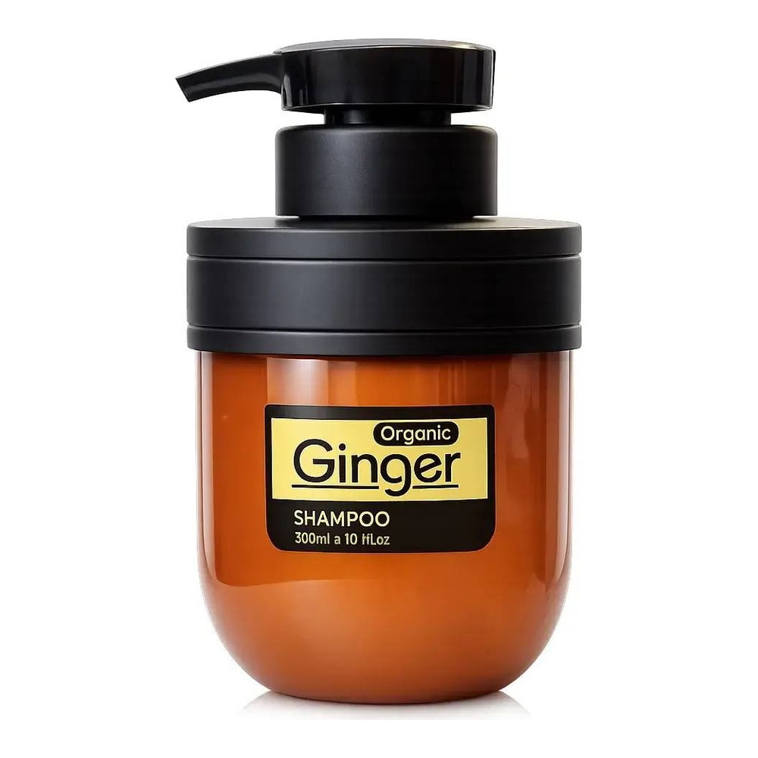 | C151623 | Organic Ginger Shampoo | 300 мл | 610 ₽ | 770 ₽
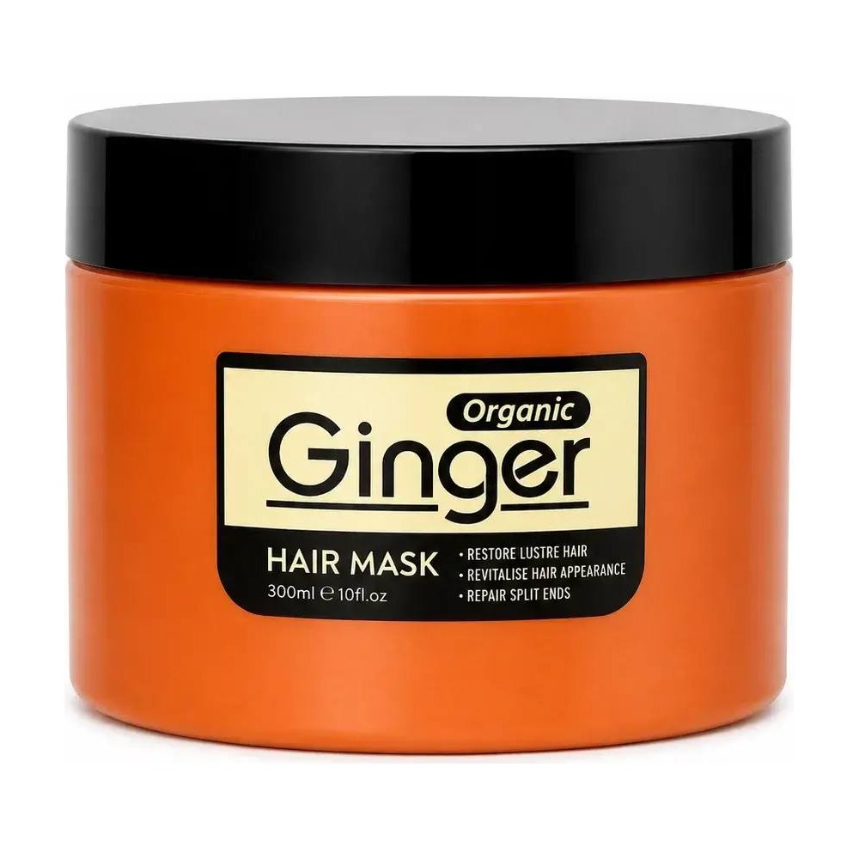 | C151622 | Organic Ginger Hair Mask | 300 мл | 760 ₽ | 950 ₽
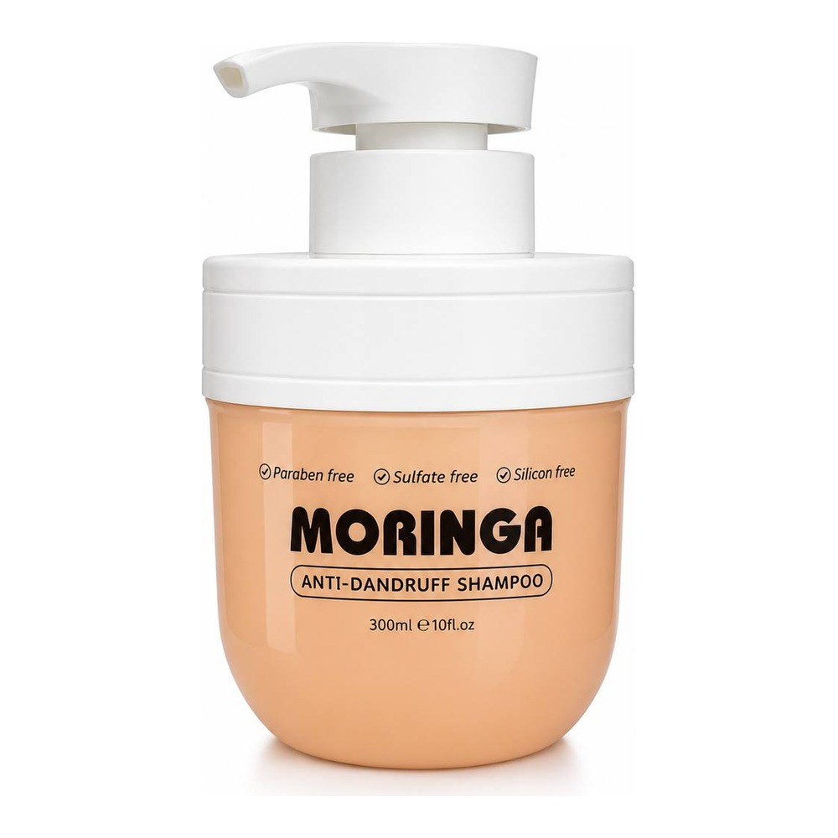 | SKAS300 | Moringa Anti-Dandruff Shampoo | 300 мл | 620 ₽ | 780 ₽
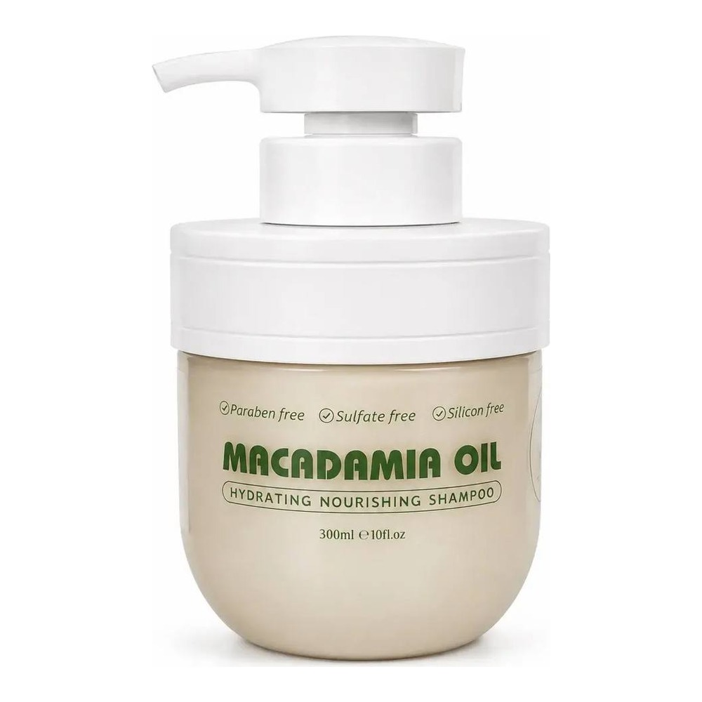 | SKMS300 | Macadamia Oil Hydrating Shampoo | 300 мл | 610 ₽ | 770 ₽
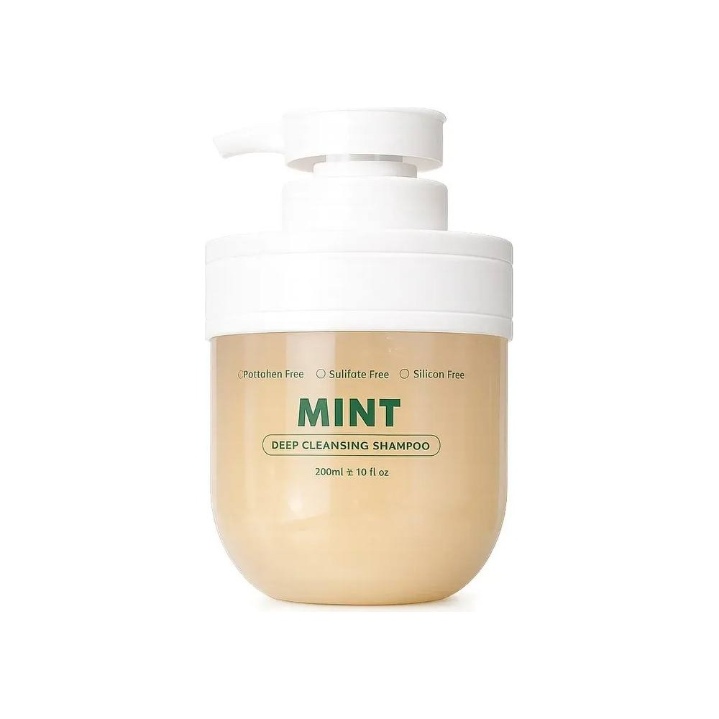 | SKDS300 | Mint Deep Cleansing Shampoo | 300 мл | 610 ₽ | 770 ₽
 | SKRC300 | Repair Silky Conditioner | 300 мл | 640 ₽ | 800 ₽
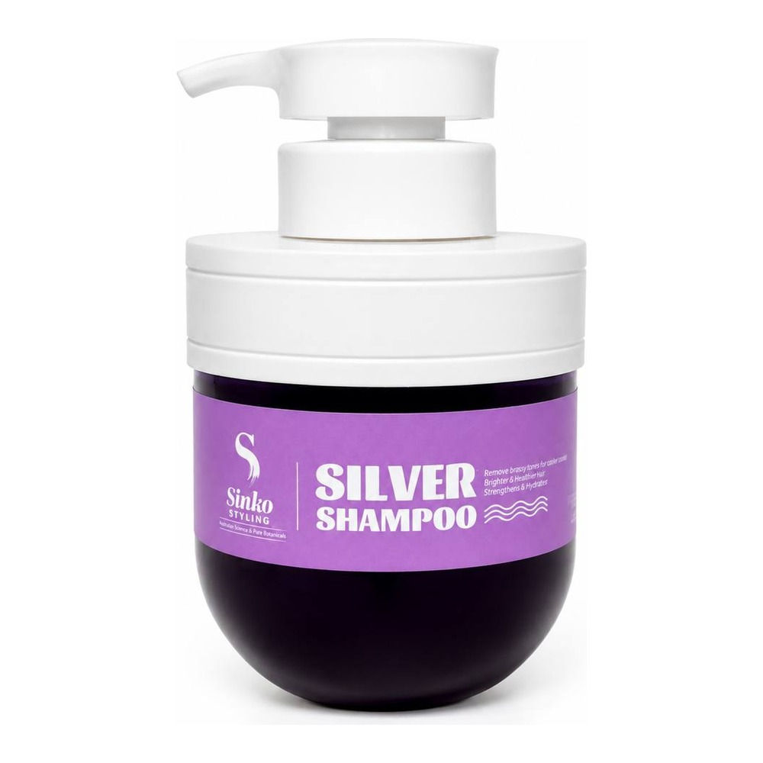 | SKPS300 | Silver Shampoo | 300 мл | 640 ₽ | 800 ₽
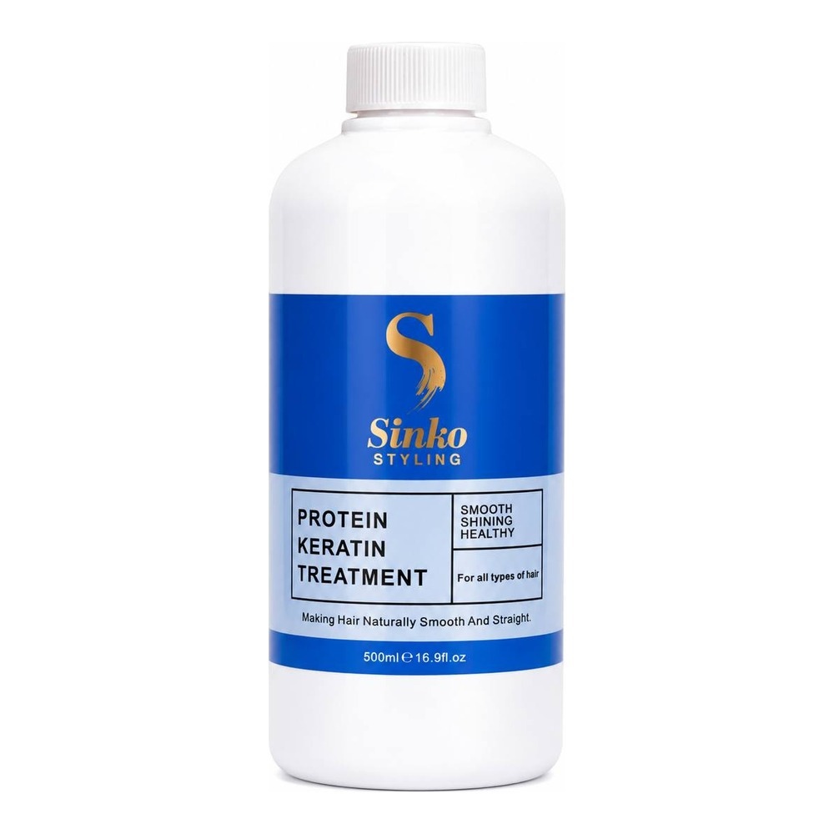 | C151058 | Glycoprotein Luxury Salon Hair Treatment | 300 мл | 1 170 ₽ | 1 470 ₽
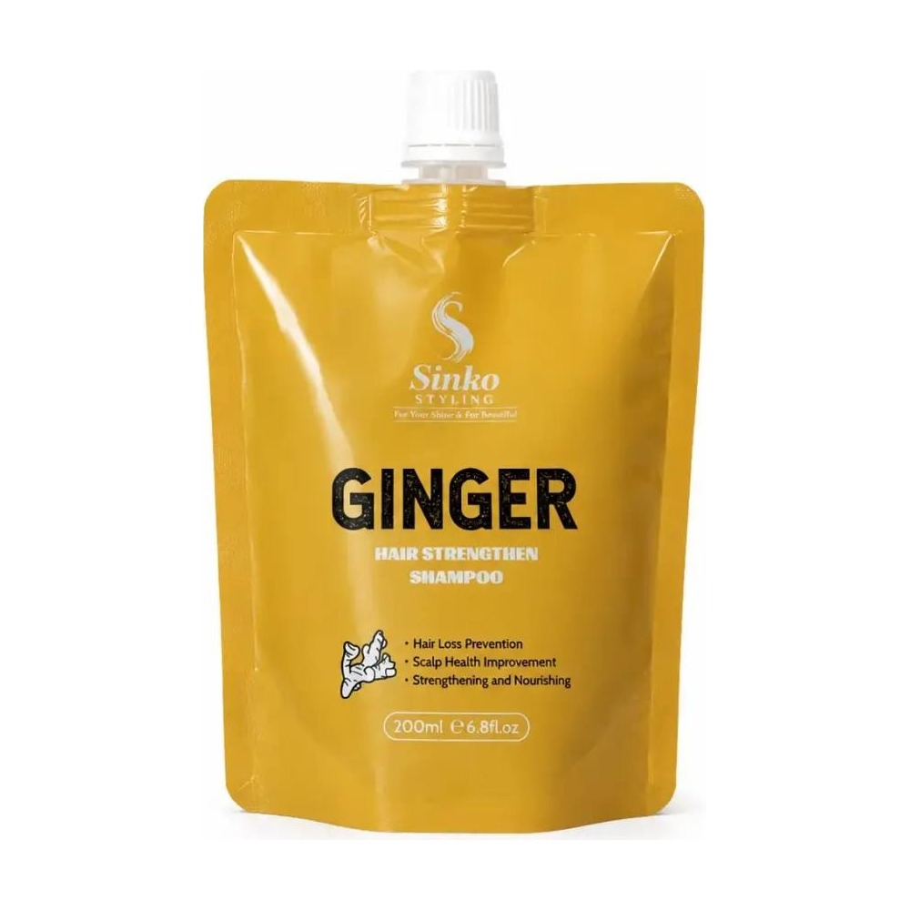 | C151624 | Ginger Hair Strengthen Shampoo | 200 мл | 440 ₽ | 550 ₽
РРЦ — рекомендуемая розничная цена. Цены указаны в рублях.

